Please note: we can provide a maximum of 25 copies of each leaflet, with exceptions listed below. If you require higher quantities a postage charge may be applied.
Name
Address
Date required by

OUR LITERATURE
Publication | Description | Quantity required
Communication Choices: your hearing, your life | An informative guide produced by Hearing Link Services and BT to explain the steps of recognising hearing loss, how to get a diagnosis and then living and managing hearing loss.  5 copies provided free of charge; higher quantities may require postage charge.
inTouch magazine | A feature magazine for Hearing Dogs and Hearing Link Services communities.  Read inspirational stories of people living with hearing loss, information about our services and products that can help you.  10 copies provided free of charge; higher quantities may require postage charge.
Do you have difficulty with your hearing? | An overview of the services offered by Hearing Dogs for Deaf People, incorporating Hearing Link Services. Find out all the ways we can support your patients, their family members, and friends.
LinkUps | A booklet which talks in more detail about our LinkUps service – offered in person and online.
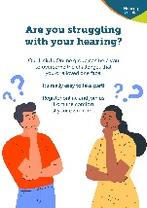  LinkUp Online (A4 flyer) | A quick guide to our LinkUp Online service and how it could help you to manage the challenges of hearing loss.
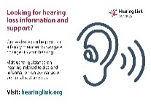  Helpdesk / Website card | Handy pocket-sized card signposting your patients to our website and Helpdesk services.
Membership flyer | Details of the Hearing Link Membership scheme and how to join and meet others with similar experiences.
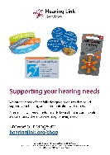  Shop flyer | Small flyer signposting to our Hearing Link Services products which provide support for hearing and communication.
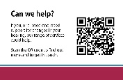  Can we help? | Our pocket-sized business card with QR code direc you to our list of services and quick-fill contact form to get in touch with our hearing loss services team.

Thank you for your support
Please email your completed forms to enquiries@hearinglink.org or if you wish to enquire about higher quantities of leaflets.

